**PROGRAM NO – 1**

**TABLE**

**AIM**

Write an HTML program to display a table as follows:

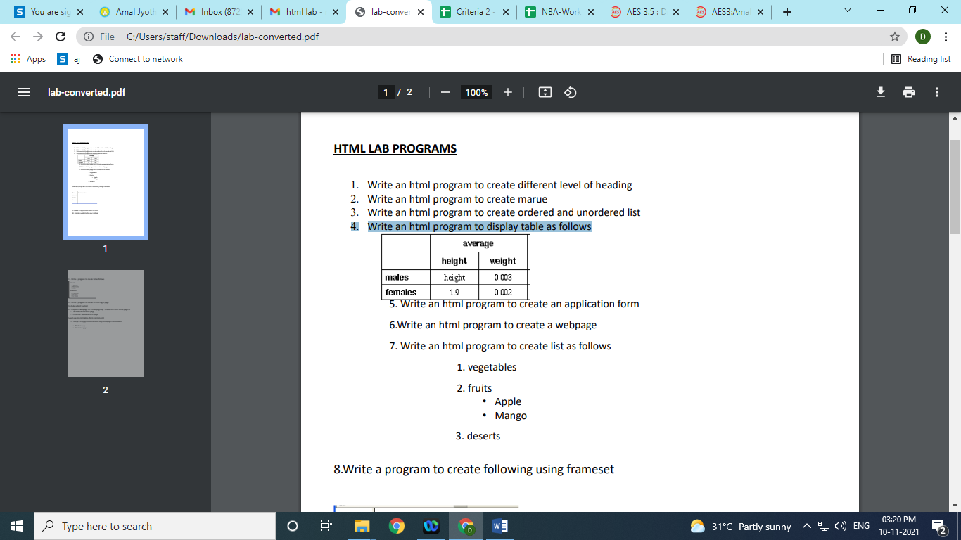

**PROGRAM**

<html>

<head>

<title>Tables</title> </head>

<body>

<table border="1">

<tr>

<td rowspan="2"></td>

<td colspan="2" align="center">average</td>

</tr>

<tr>

<td>height</td>

<td>weight</td> </tr>

<tr>

<td>males</td>

<td>height</td>

<td>0.003</td>

</tr>

<tr>

<td>females</td>

<td>1.9</td>

<td>0.002</td>

</tr>

</table>

</body>

</html>

**RESULT**

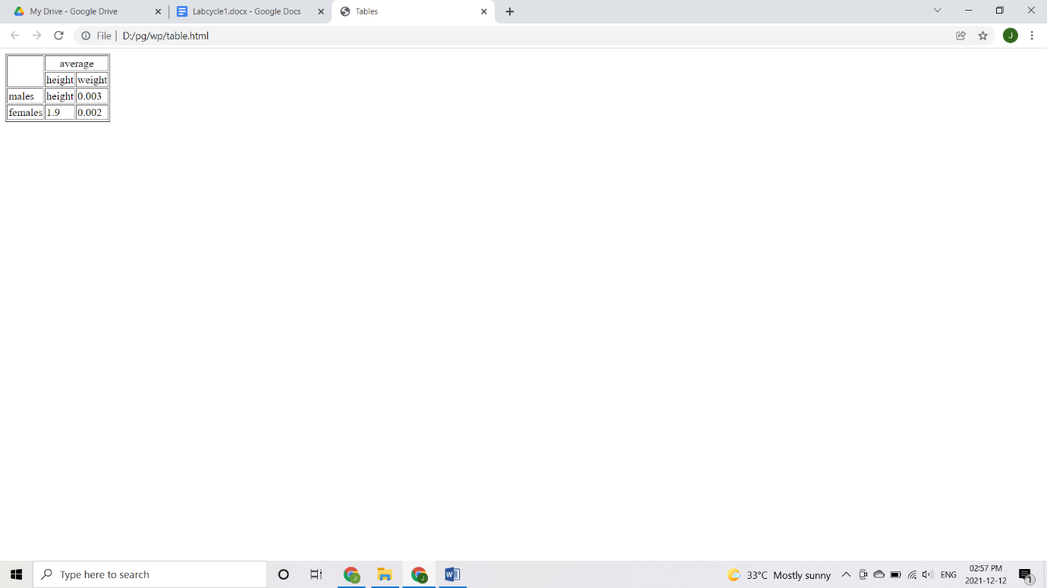

**PROGRAM – 2**

**LIST**

**AIM**

Write a program to display a list as follows:

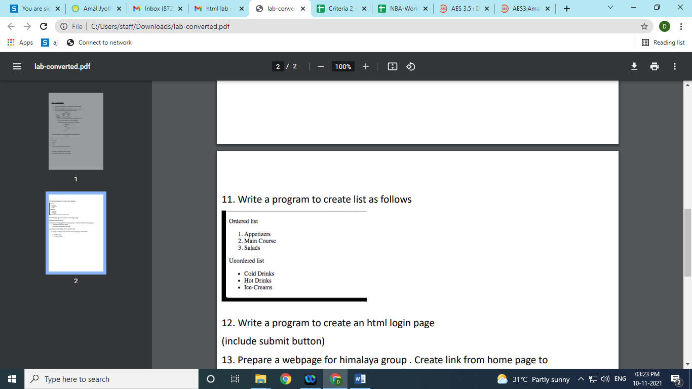

**PROGRAM**

<html>

<head>

<title>List</title>

</head>

<body>

<p>Ordered List</p>

<ol type="1">

<li>Appetizers</li>

<li>Main Course</li>

<li>Salads</li>

</ol>

<p>Unordered List</p>

<ul type="bullet">

<li>Cold Drinks</li>

<li>Hot Drinks</li>

<li>Ice Creams</li>

</ul>

</body>

</html>

**RESULT**

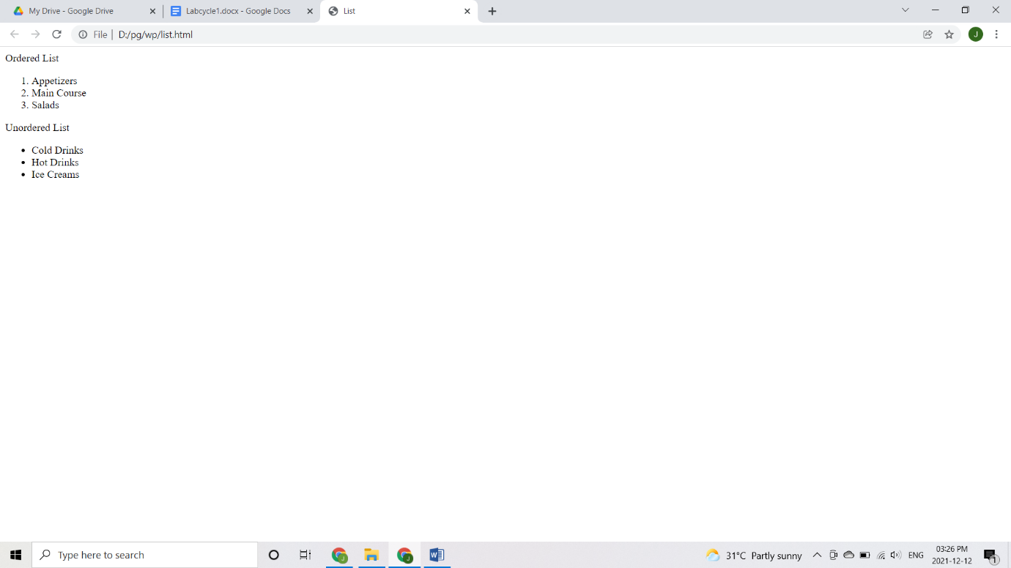

**PROGRAM NO – 3**

**WEBSITE**

**AIM**

Design a website of your college which contain home page, department and about us using html (use image, tables and links).

**PROGRAM**

**about.html**

<html>

<body>

<h3>AMAL JYOTHI COLLEGE OF ENGINEERING</h3>

<p>A CHRISTIAN MINORITY INSTITUTION MANAGED BY THE CATHOLIC DIOCESE OF KANJIRAPPALLY</p>

<p><u>VISION</u></p>

<p>To be a center of excellence in technical higher education, research<br>and support services, capable of making significant contribution<br>to

individual and societal empowerment.</p>

</body>

</html>

**dept.html**

<html>

<body>

<h2>Amal Jyothi College of Engineering</h2>

<h3>Departments</h3>

<table border="1">

<tr>

<th>s.no</th>

<th>department</th>

</tr>

<tr>

<td>1.</td>

<td>chemical engineering</td>

</tr>

<tr>

<td>2.</td>

<td>master of computer applications</td>

</tr>

<tr>

<td>3.</td>

<td>civil engineering</td>

</tr>

<tr>

<td>4.</td>

<td>mechanical engineering</td>

</tr>

</table>

</body>

<html>

**home.html**

<html>

<body>

<image src="C:\Users\ASUS\Downloads\w.jpg"><br>

<a href="about.html">About Us</a><br>

<a href="dept.html">Departments</a>

</body>

</html>

**RESULT**

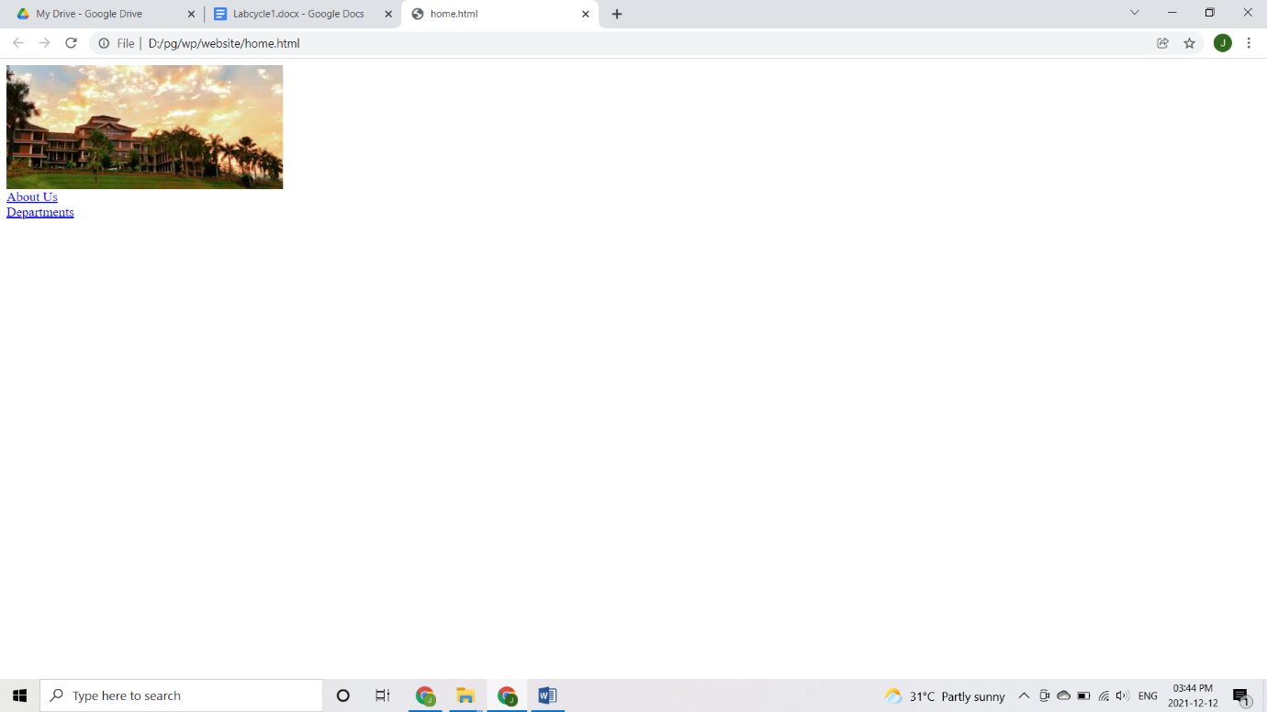

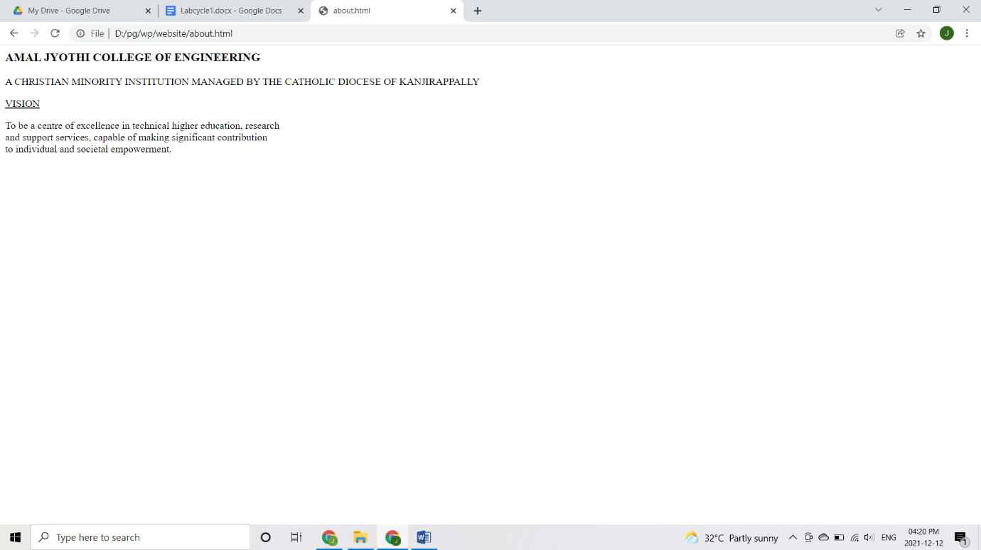

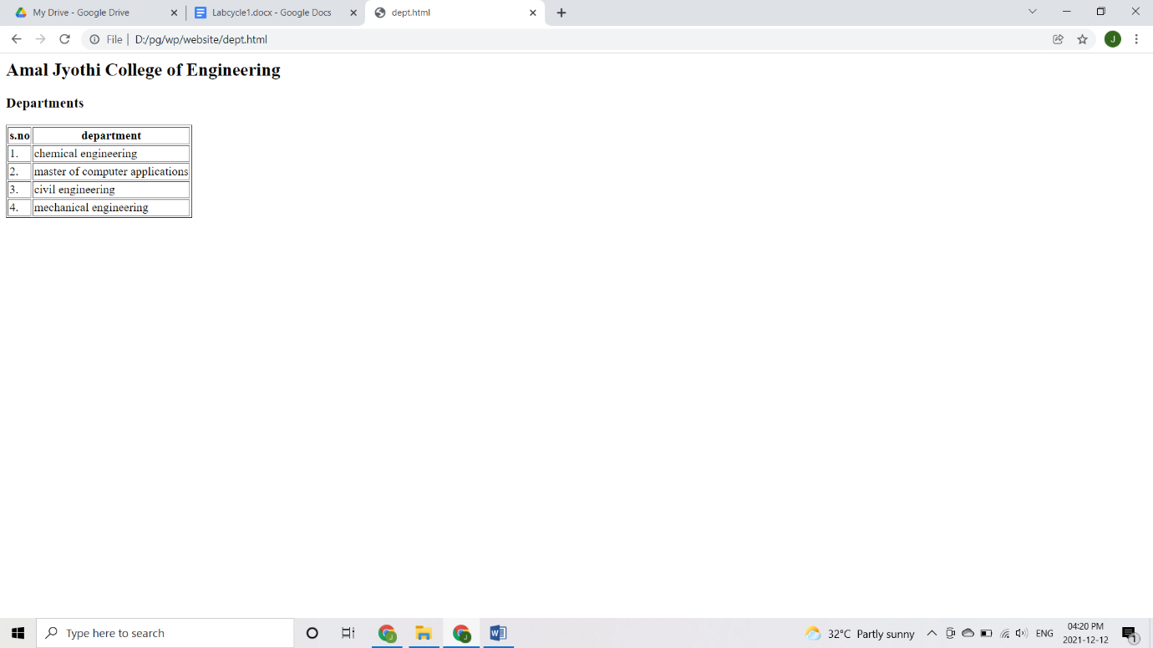

**PROGRAM NO – 4**

**FRAMES**

**AIM**

Create an html page with different types of frames such as floating frame (iframe), navigation frame and mixed frame (horizontal and vertical).

**PROGRAM**

**float.html**

<html>

<body>

<iframe src="http://www.javatpoint.com/">

</iframe>

</body>

</html>

**frame1.html**

<html>

<body>

<a href="nav.html">navigation frame</a><br>

<a href="float.html">floating frame</a><br>

<a href="mixed.html">mixed frame</a><br>

</body>

</html>

**frame2.html**

<html>

<body>

<h2>iframe</h2>

<p>javatpoint website</p>

<iframe src="https://www.javatpoint.com/"height="50%" width="70%"></iframe>

</body>

</html>

**frame3.html**

<html>

<frameset cols="25%,*">

<frame src="frame1.html"></frame>

<frameset rows="50%,*">

<frame src="frame2.html"></frame>

<frame src="C:\Users\ASUS\Downloads\w.jpg">

</frame>

</frameset>

</html>

**mixed.html**

<html>

<frameset cols="25%,*">

<frame src="frame1.html"></frame>

<frameset rows="50%,*">

<frame src="frame2.html"></frame>

<frame src="C:\Users\ASUS\Downloads\w.jpg"></frame>

</frameset>

<html>

**nav.html**

<html>

<body>

<label>hello:</label>

<input type="text" name="fname"/><br><br>

<input type="submit" value="submit"/><br><br>

</body>

</html>

**RESULT**

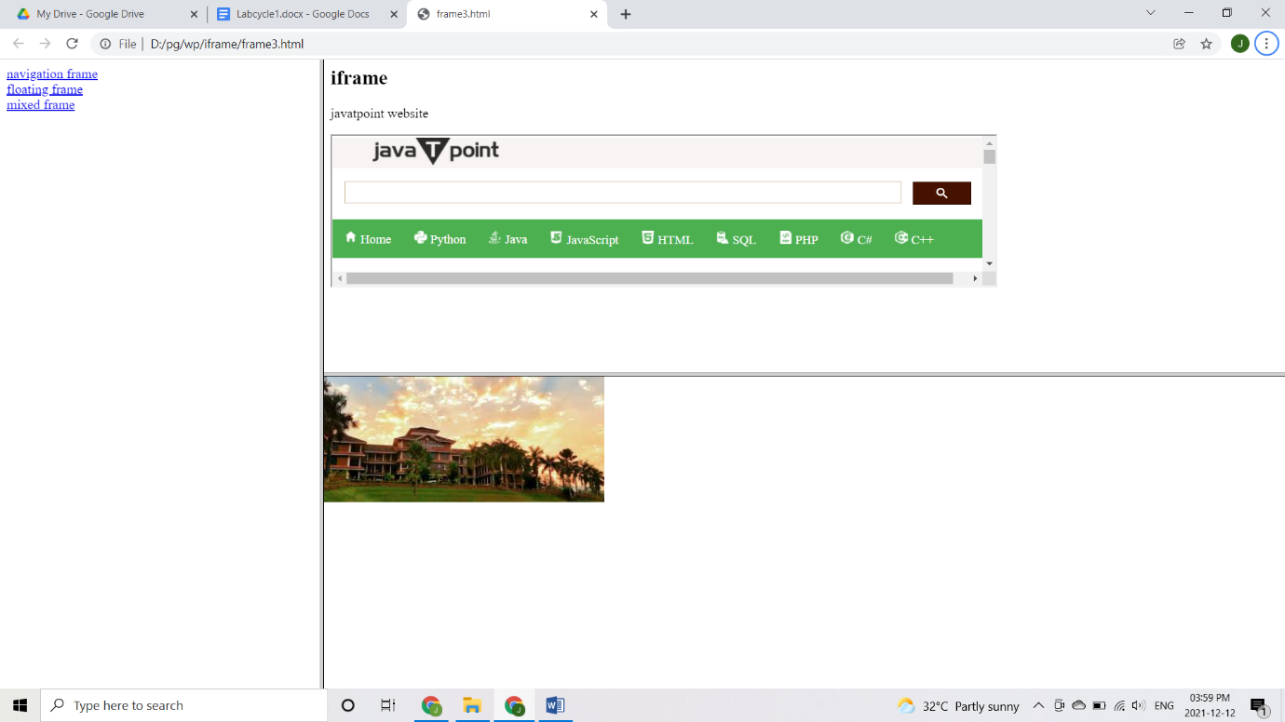

**PROGRAM NO – 5**

**REGISTRATION FORM**

**AIM**

Demonstrate a registration form using HTML.

**PROGRAM**

<html>

<head>

<title>Registration Form</title>

</head>

<body>

<form>

First name: <input type="text" name="f_name"/>

<br><br>

Last name: <input type="text" name="l_name"/>

<br><br>

Age: <input type="text" name="age">

<br><br>

Gender:<br><br>

<input type="radio" name="gender" value="female">Female

<input type="radio" name="gender" value="male">Male

<input type="radio" name="gender" value="male">Other

<br><br>

Course:<br><br>

<select name="dropdown">

<option value="bca" selected>BCA</option>

<option value="mca">MCA</option>

<option value="btech">B.Tech</option>

<option value="mtech">M.Tech</option>

</select><br><br>

Address:<br><br>

<textarea rows="5" cols="50" name="address">

</textarea><br><br>

Phone no: <input type="text" name="phno"/><br><br>

Email id: <input type="text" name="eid"/><br><br>

Pasword: <input type="password" name="pwd"/><br><br>

<input type="submit" name="submit" value="Submit">

</form>

</body>

</html>

**RESULT**

